CLC - Assignment 2: Monitors and Semaphores

CST-315 Operating Systems

Nathan Dilla, Angel Velazquez

February 18, 2024

**Names, Roles, and Tasks Completed by Each Member**

*Nathan Dilla* **-** Wrote documentation for the CLC, wrote code

*Angel Velasquez* **-** Wrote documentation for the CLC, wrote code

**Implementation**

Explanation of approach of implementation and reasoning

This is a computer-based solution to meet a given set of computing requirements. This project includes two programs that utilize monitors and semaphores separately. There are two processes: Producer and Consumer. The Producer process creates numbers passed to the Consumer process via a static buffer. Functions, get() and put() will use the buffer to ensure that the Consumer is not waiting for the Producer to make more numbers and that the Producer process maintains ahead of the Consumer process. As per the requirements, we were asked to implement this project without using threads, which is the equivalent of wearing shorts in the snow.

**Successful Compilation of Program Files**

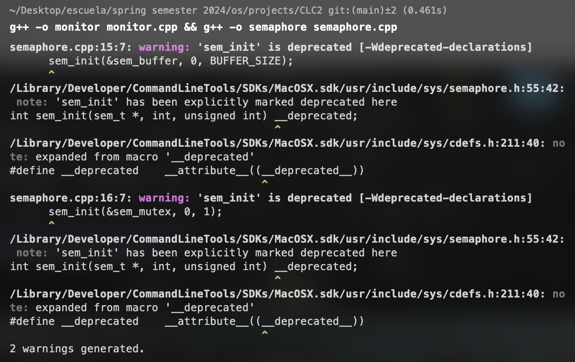

Upon closer inspection of the semaphore compilation, you may see two specific warnings thrown. The semaphore file utilizes deprecated functions to initialize semaphores, but the warnings may be ignored as the program runs as expected.

**Successful Execution of Programs**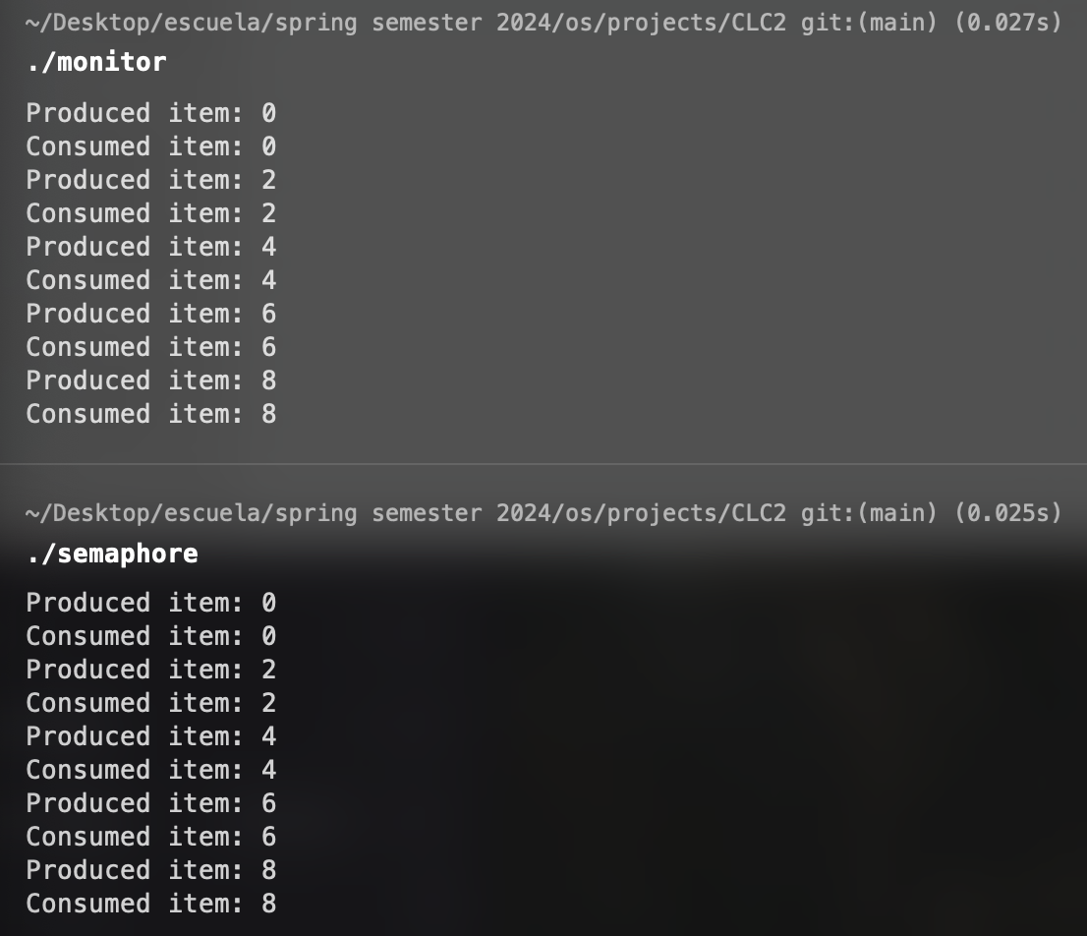

**Repository Link:**

https://github.com/angel-vlzqz/Operating-Systems/tree/main/projects/CLC2